Problem Solving
Being good at math isn’t really about knowing the steps to solve lots of different kinds of problem. That’s maybe what it means to be good at math in school. Math itself is a lot more creative and exploratory.
Mathematicians usually distinguish applied math from pure math. Roughly, applied math is figuring out how patterns we know about can be used to solve new practical problems. Pure math is discovering and describing new patterns that seem interesting (and may be helpful some day).
Either way, being good at math has more to do with your ability to explore or investigate a situation and figure out how the patterns you find connect to ideas you know something about already. So, you do need to know some facts, but the key verbs here are investigate and connect. Students usually don’t get a lot of practice developing these creative ways of thinking.
Investigating and then having an insight (seeing a connection) is a great joy! It feels creative and fun. But you also can’t be worried about speed or efficiency. You also can’t expect to see anything useful the first, or second, or even 10th time you look. The Danish mathematician Piet Hein said “Problems worthy of attack prove their worth by fighting back”. The idea is that problems that you can solve right away aren’t very deep or interesting. When a problem resists solving, it’s often a sign of an important problem.
Your Life Solving Problems
When you encounter a problem, one of two things will happen:
1). You’ll immediately recognize that this is a problem you know how to solve.
2). You won’t have any clear idea what to do.

What can you do in situation 2? Clearly you could ask someone (your friend, an AI). If the answer is all that matters, and it’s not important if you can think clearly about it yourself, that’s fine.
If you don’t like being dependent on others, or you like the feeling of having your own insights, or if it’s a question your friends and the AI can’t seem to answer, then you’ll need strategies.

How can you tackle a problem when you don’t see what you can do?
Here are five problems where you might look at them and think I have no idea what to do.
Problem 1. I’ve got two square boxes, lengths 4 and 7. I want to know how big a 3rd box needs to be so that its corner will touch a straight 2x4 piece of lumber I place supported by the corners of the other two boxes. (The large box in the diagram needs to be a little bit bigger, since it isn’t supporting the beam).
?
4
7

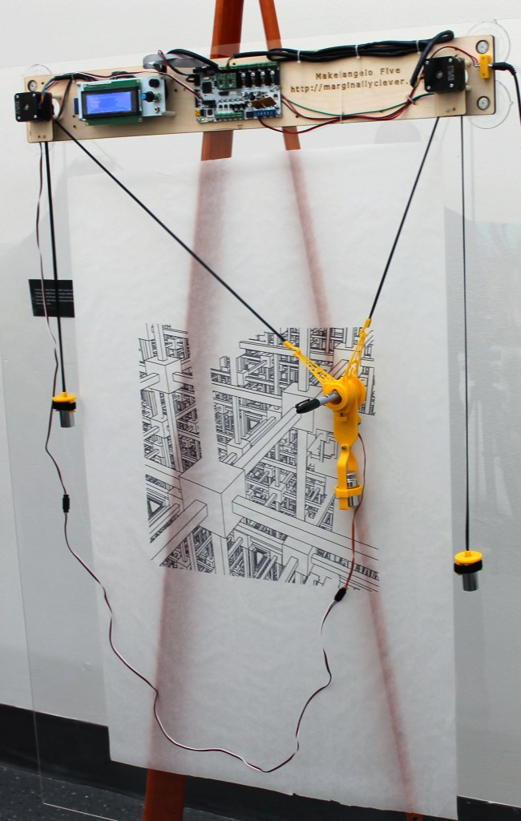
Problem 2. This problem is both harder and more realistic, but one you can still solve with math from algebra 2/trig. These pictures show a robotic plotter that draws pictures on a vertical paper.

The way it works is that the stepper motors rotate to take in or let out enough string that the pen will be hanging at the right place where you want to draw. To draw, you tell the motors to rotate and either take in or let out more string so the pen will move and hang at a new location. (The craddle that holds the pen also has a small motor that can hold the pen down so it will draw, or hold the pen away from the paper if you want to move without drawing).
(24, 13)
These black boxes are stepper motors
The math problem is figuring out how to control the motors. If we know some (x, y) coordinates on the page where we want to start drawing a line, what lengths of string do there need to be on the left and the right for it to hang at that position?
In the picture on the right I’ve added axes and the (made up) coordiantes (24, 13). What two lengths of string would make it hang at that position?
Of course, we don’t really care about the point (24, 13). Instead we need a general method of figuring out what lenths of string correspond to any point $(x, y)$.

Problem 3. If I multiply two 100-digit prime numbers and give you the product, can you easily (quickly) figure out what my two original primes were?
If you don’t know, a prime number is a number that is only divisible by itself or 1. For example, 11 is only divisible by 1 and 11, whereas 12 is divisible by 1, 2, 3, 6, and 12.
The number: *** DO IT ***
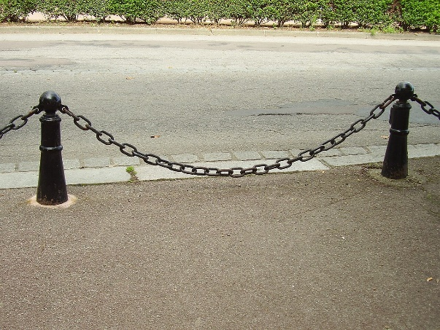
Problem 4. What mathematical equation describes the shape of a chain hanging between two points? If I told you the hights of the two points, could you predict, exactly, the height of the chain at any horizontal distance x from the left point?

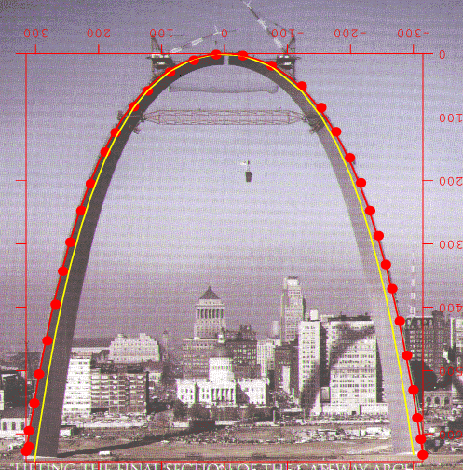
Problem 5. What’s the most stable shape for building an arch?
By “stable” here, we don’t just mean “won’t fall over”. We actually mean something a little more technical.
Many materials are very strong when you try and compress them, but much weaker if you try and pull or bend them.
If we’re going to build an arch out of concrete, stone, or blocks joined with mortar, we want as much of the force as possible (ideally all of it) to be compressing the material instead of bending it.
An arch that’s a half circle can certainly stand up, but a lot of the force will act in a way that bends the shape, so it might need thicker material in certain spots, or other types of support.
So, how can you tackle a problem when you don’t see what you can do?
Let’s be real. If you don’t see how to solve a problem, sometimes you really can’t solve it without knowing more math.
Problems 4 and 5 are actually the same problem, and you can’t really solve them without calculus. The shape of the most stable way to build an arch is the same type of curve as the hanging chain, just upside down. Galileo (b. 1564) really wanted to solve this problem, but he didn’t know calculus (developed in the late 1600’s). He was convinced these shapes were parabolas (the family $y=x^{2}$). They’re actually a type of curve called the hyperbolic cosine (usually written $y=cosh⁡(x)$ ).
The hanging chain’s shape is determined by a balance of forces at every point along the chain. Each bit of chain is being pulled in 3 directions: from the segment to the left, from the segment to the right, and straight down by gravity.
Using calculus you can write an equation for these three forces and work out the equation for the curve you’d get when all 3 forces are balanced. (The equation for hyperbolic cosine turns out to be $y=\frac{e^{x}+e^{-x}}{2}$ when you derive it). Without calculus, you can try and approximate measurements or set up physical models, but you can’t really derive the exact curve.
* * *
Sometimes, if you don’t see how to solve a problem, it’s because it’s so hard no one knows how to solve it. Problem 3 is a problem that is currently unsolved. It’s so hard that researchers invented an encryption algorithm that’s only secure so long as no one can solve it. The RSA encryption algorithm is used whenever you visit a website and it needs to prove that it really is the site it claims to be. The algorithm is only secure because no one knows how to answer question 3. If a mathematician were to figure out the answer, a great deal of the worlds computers would become vulnerable to hacking.
* * *
BUT, a lot of the time if you don’t see how to solve a problem, you really can solve it with math you know, you just don’t see how yet. That’s the situation for problems 1 and 2. Problem 1 can be solved with middle-school math, and problem 2 can be solved with algegra 2 and trigonometry.
So: If you’re going to solve a problem using math you know, you need a way to see how the math you know connects.

Problem Solving Strategies
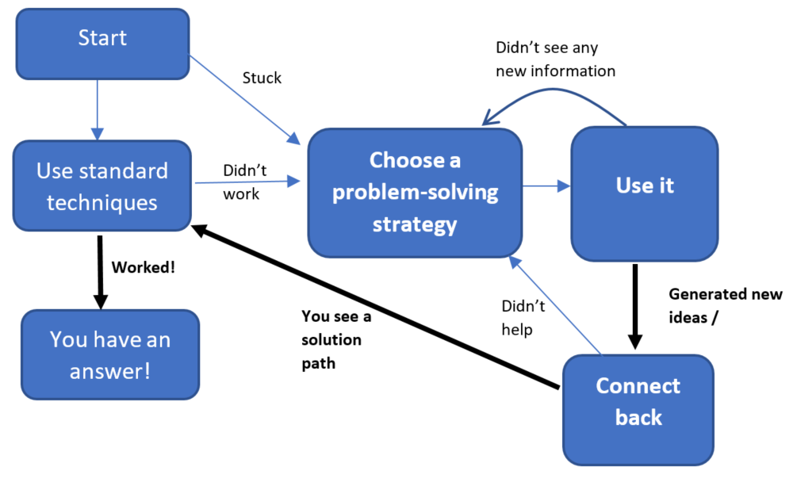
Problem-solving strategies are things you can try when you don’t know what to do. The goal is to learn more about your problem or see it from a new perspective that will make it more likely you’ll see how math you already know connects (“ooooh, I can just use the pythagorean theorem to solve this! I just couldn’t see it before”). If you like a flow-chart, here’s more or less how they work.
Problem Solving Strategies

You don’t need them if your standard techniques work. But, you’ll notice, that the solution in the end will still involve standard techniques. You just need to see how they apply.
If you ask most mathematicians, they will come up with similar lists. Here’s one my calc class came up with at the end of the year in 2014.
List my Calculus class came up with in 2014

- Explore small/simple examples
- Generalize / find a pattern
- Write down what you know and what you want to know using math notation
- Look at the tools you have
- Make a diagram
- See what else you can figure out with the information you have
- Look for things that are familiar
- Break it down into small pieces
- Do one part at a time
- Represent the problem in different ways
- Look for special cases
- Solve a related or simpler problem
- Change the question slightly
The mathematician George Pólya was the first one to try and systematically write down what he considered to be standard practice for his mathematical peers (in his book How To Solve it). His list is similar.
The Park Slope Math Curriculum class them “habits of mind” and gives the following (slightly pruned) list:
- Tinker
- Describe
- Visualize
- Represent symbolically
- Check for plausibility
- Take things apart
- Conjecture
- Change or simplify the problem
- Work backwards
- Change representations
How do you use them?
They aren’t step-by-step procedures that will lead to the answer. They’re just a bunch of different suggestions for enlarging your understanding of what you’re working on in the hopes you’ll see a new thing to try.
We’ll start with just a few (not the whole list!) and see how they work. Then you can use them whenever you’re stuck on a problem.
Based on what I saw last year in class, I'd estimate that about 80% of the time a group got stuck on an everyday problem, their eventual solution involved one of these strategies.
Our plan.
We’ll introduce these problem solving techniques a few at a time, and let you practice them with feedback and advice so you can start to get the feel for them.
If you’d like to tackle some puzzles now, here are a few you can use that don’t required advanced math, but which are definitely tricky to think about.

Problems To Try
Here are some problems to try. They can all be solved with math from algebra 1 or earlier, but are difficult nonetheless.
Don’t worry if you can’t solve them; they’re supposed to be tricky! Practicing using these techniques is something you’ll do throughout the year.
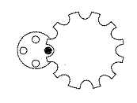
1. Clocking mechanism. Here is a clock mechanism with four pegs (left) and 12 notches (right). Imagine them rotating.
a. How many of the 12 notches will get “touched” by the black peg as they spin.
b. What if there are 5 pegs and 12 notches?
c. For what numbers of pegs and notches will a black peg touch every notch? In those cases, will every peg touch every notch? How can you tell?
d. For any number of pegs and notches, how can you easily calculate how many notches will get touched by a peg?

2. Two ways of resting. If you get tired while running, you might rest by walking for some amount of time (“I’ll just walk for 30 seconds”), or by walking for some distance (“I’ll just walk for then next 100 yards”), before you start running again. That made me imagine the following (somewhat vague) scenario:
Two people who run and walk at the same speeds, are doing the same long distance running trail. At the end, one person realizes that they walked exactly half the total distance of the trail. The other person realized that they spent exactly half their total time walking.
I have a few questions about this scenario:
a). Who won, or did they tie? Does the answer depend on the length of the trail? Why or why not?
b). If one person wins, by how much (in time) does one eat the other? What parts of the problem does that gap depend on? (in other words, what could we change about the problem which would change that winning amount?)
c). How many times can they be side-by-side?
d). What if, instead of walking half the time or half the distance, the fraction were different. What if one of them walks for $\frac{1}{10}th$ of the time and the other for $\frac{1}{10}th$ of the distance? Does that change your analysis at all?

3. Water rising. The base of a rectangular tank is three feet by two feet tall. The water in the tank is 9 inches deep. The water will rise when I place a one-foot metal cube on the bottom of the tank.
a. By how much?
b. How much will it rise when I place a second one-foot cube in the tank?
c. If the original tank were a cylinder with a circular base whose area is 12 square feet, are your answers the same, or different? How do you know?

4. Substitution cipher
A cipher is another name for a code. A substitution cipher is a code where you replace every instance of one type of letter with another. For example, you might replace every 'a' with a 'c', every 'b' with a 'd' every 'c' with an 'e' and so on.
Here is a short message that I've created with a substitution cipher that shifts ever letter up by 3 in the alphabet. (I’ve kept the punctuation the same as the original message, but, of course, someone could decide that spaces and punctuation should be part of the cipher).
wklv lv d vhfuhw phvvdjh. fdq brx pdnh d kdughu frgh?
Below is the same message, but now I’ve encoded it differently. Instead of every letter “shifting” by 3, I’ve replaced every letter by a different one.
evjh jh x hlmsle blhhxkl. mxn ztu bxgl x vxhsls btpl?
Check the footnote to see the particular cipher I used.
Here are some questions I was thinking about:
a. If I keep applying my first cipher (shift by 3), over and over again, will the text ever end up unscrambled? How long (how many repetitions) will it take?
b. Can you find a cipher that will create the unscrambled text if you apply it twice in a row? What about three times in a row? What about 27 times in a row?
c. What's a cipher that will take the longest (the most repeated applications) to return to the unscrambled text. How many repeated applications are required? How do you know your cipher will take the longest?
5. Sheathing Diameter
You work for a company that makes custom cables. It bundles cables together inside a larger, hollow tube (the sheath) as shown here.
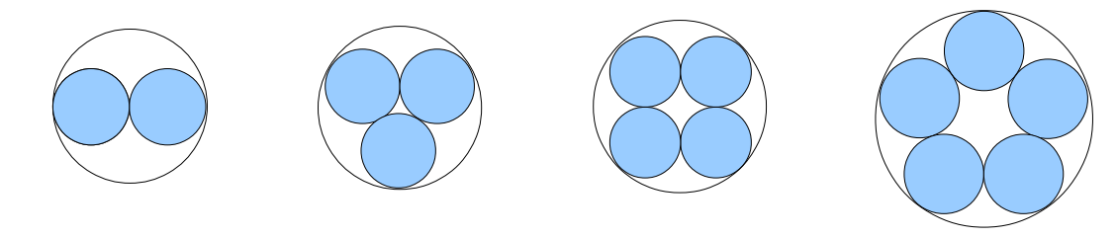
a). If the smaller cables have diameter d, what’s the diameter of the larger sheath for each picture above?
b). A harder question that might take more than just algebra 1 skills is: with larger numbers of circles, how can you figure out the way of arranging them that will result in the minimum diameter sheath?

a→x b→q c→m d→p e→l f→r g→k h→v i→j j→y k→g l→f m→b n→n o→t p→o q→c r→s s→h t→e u→u v→w w→d x→a y→z z→i

